Unit3 A taste of English humour
Unit3 A taste of English humour
第7周第1课时 编号：23 课题： Words
编写人： 班级__________ 姓名__________ 师评__________
一、学习目标
Read the words and the expressions in this unit
二．学习重点
Lead the students to read the vocabulary in part1 correctly.
三、学习方法
1. Refer to the vocabulary list (p97-98) in students’ book and finish part1
2. Group work to finish part2 and part3
四、学习过程
Part1.自主学习
1. Read the following words and phrases and then write their meanings on the lines.
A. words
humour_________ comedy________ content________ performer_________
astonish________ fortunate_________ ordinary_______ bored_________
entertain_________ throughout________ homeless_______moustache _________
worn_________ failure________ overcome________ leather_________
chew________ convince ______ direct_________ outstanding_________
Switzerland_________ gesture________ particular_______occasion _________
budget_________ actress________ overcome________ leather_________
B. phrases
up to now_________ be content with_________ badly off_________
Worn out_________ pick out_________ cut off_________star in_________
2. Write the right form of each word and read them out (参阅课本p97-98) .
humour __________ (adj.) performer________ (n.) astonish_________(adj.)
fortunate_________(adv.) entertain_________(adj.) convince_________(adj.)
confidence________(adj.) particular________(adv.) amuse_________(adj.)
explanation_________(v)
Part2.合作探究
Choose the right form of the given words to fill in the blanks.
1._________(humourous) is important to a successful man.
2.The actor put on a fine_________(performer).
3.It was________(astonish)to everyone that the court had made such a decision.
4. _________(fortunate),he gave up learning English.
5.I know you found I the most_________(entertain).
6. Such (convince) speech will at last win the applause of her heart.
7.She is a_________(confidence)girl in our class.
8. I (particular) mentioned that point.
9.The lawyer (explanation) the new law to us.
10. The story of the book 's origins is (amuse)
Part3.课堂检测
Words spelling
1.It seems that he is quite _________ (满意)with what he has got.
2.We were all ___________ at the _________ (惊讶)news he told us just now.
3.It’s hard for her to decide what to buy because she is quite ___________(特别的) about the things she buys.
4.Whoever comes, my mother will _________ (招待)him the best food of our family.
5. In no time, the exciting news spread _________ (遍及;贯穿)the whole country.
6. Because of the terrible earthquake, many children became ________(无家可归的).
7. Many of us know the famous saying ________(失败) is the mother of success.
8. I am__________(厌烦)of the speech.
9. He was determined to _________(克服) the difficulties he met in his study.
10.I was _________(幸运的) to catch the train at the last minute.

Warming up&speaking
一、学习目标
Talk about different types of humour; a taste of English humour
二．学习重点
Memorize the words and expressions in this unit
三、学习方法
1.Refer to the vocabulary list (p97)
2.Group work to finish part2
四、学习过程
Part1.自主学习
1. Read the following words and phrases and write their meanings on the lines.
humour________ comedy________ content________ performer________ astonish________ astonishing ________ fortunate_______ unfortunately ________ ordinary________ bored________ entertain_______ throughout________ homeless________ moustache ________ failure________ overcome________ leather________ chew_______ convince _______ direct _________
outstanding ________ Switzerland ________
2Phrases
直到现在___________ 对…感到满意__________ 穷的__________
挑出t________ 切断__________ 在…中担任主角 ___________
3. Fill in the blanks.
1. _______ you _________ your present salary？(对….满意)
2. She was _____________ to find he was drunk .(吃惊)
3. He is a _________(无家可归的) boy.
4. Zhao Benshan is a __________(幽默的) actor.
Part2.合作探究
Task1 Enjoy the following pictures.
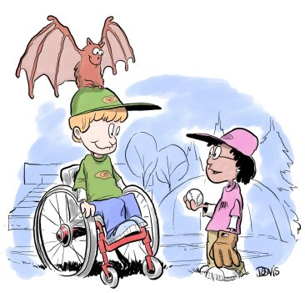 "I've heard of a little black rain cloud, but this is ridiculous"

"That's not exactly what I meant when I said, 'Bring your bat'!"
2 Teacher: You say that John Jones has a cold and cannot come to school today. Who am I speaking to?
Voice: Oh, this is my father.
3.
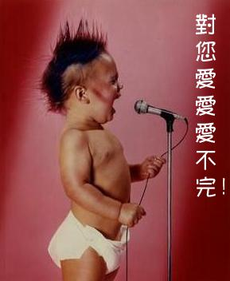 Do you feel my love?
4.

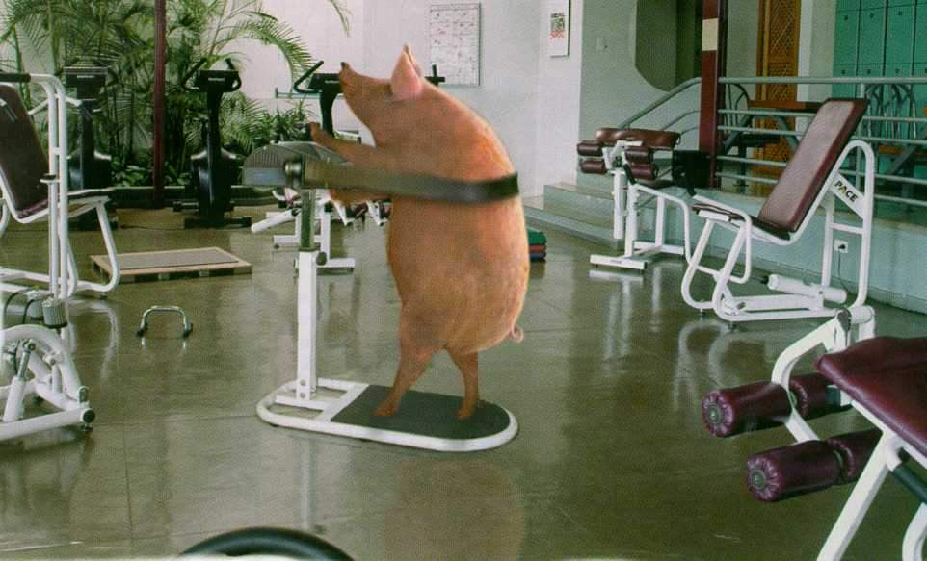 I want to lose weight.
5.
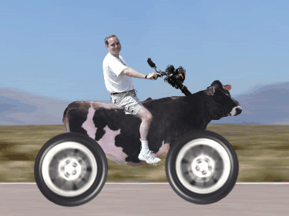 I’m driving at a high speed.
Task2.How many kinds of humour do you know?
Types of humour
jokes sketch(小品) mime ( 哑剧) comedy funny stories cross talk (相声) funny poems funny film
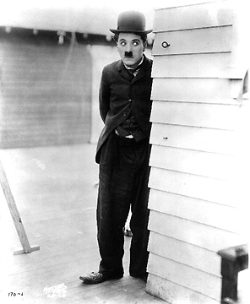( )  ( )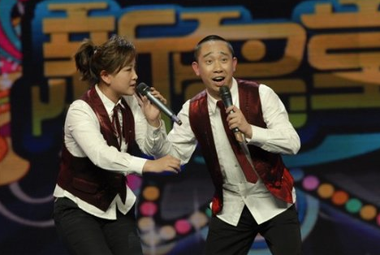( )
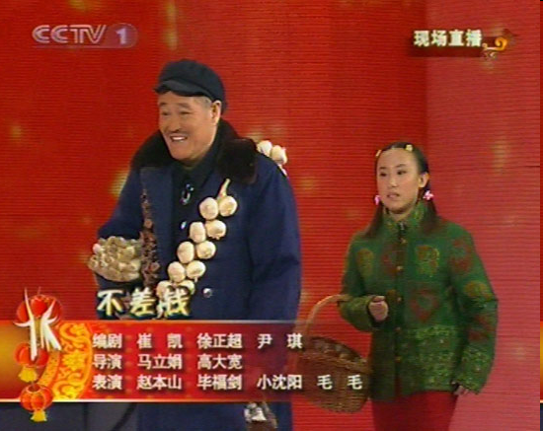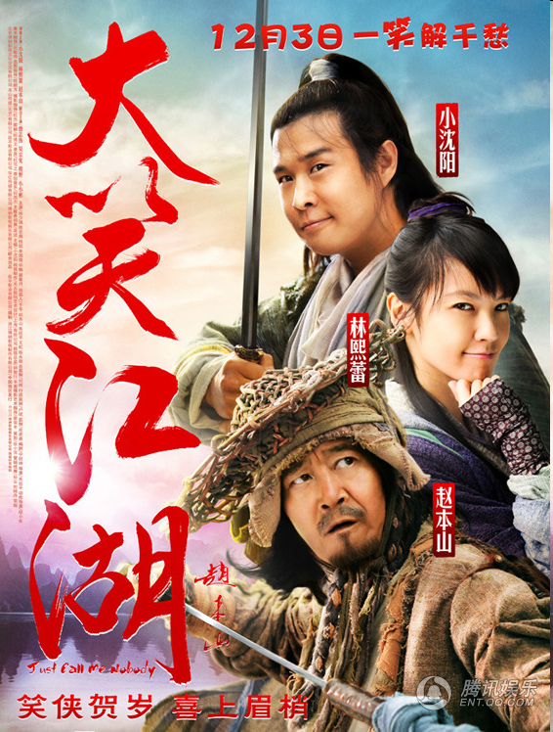
( ) ( )
Which do you like best?
I like________________ best.
Unit3 A taste of English humour
Reading the text (1)
编写人： 编写时间：
审核人__________ 审批人__________
班级__________ 姓名__________ 组号________ 组评__________ 师评__________
一、学习目标
1. Understand the text (para1-3by reading
2. Recite and analyze the related key sentences
3. Learn about the some words and expressions
二．学习重点
Memorize the words and expressions in this unit
三、学习方法
1. Refer to(查阅) the notes (No.1-3) in p32-33(《专家半读》)and finish part2 teamwork
2. Individual work to finish self-learning(自主学习)
四、学习过程
Part1.自主学习
Translate the following into Chinese and read them aloud
1. feel more content with their lives______________________________.
2. you may find it astonish_____________________________.
3. unfortunately his father died_________________________.
4. leave the family worse off__________________________.
5. this character was a social failure______________________.
Part2.合作探究
Task1. read aloud
1.Read paragrah1-3aloud after the teacher
2.Read them aloud to your partner to check your pronunciation(读音)mistakes.
Task2.Translation
1. He made people laugh at a time when they felt_________ , so they could feel more ____________ their lives.
____________________________________________________________________.
2. You may find it _______ that Charlie was taught to sing as soon as he could speak and dances as soon as he could walk .
____________________________________________________________________.
3. ______________ his father died, leaving the family worse off, so Charlie spent his __________ looking after his___________ and his brother.
_____________________________________________________________________
_________________.
4. This character was a social failure but was loved for his__________ and determination to ________________.
_____________________________________________________________________.Task3. Learn and master the following notes
1.content adj 意思是_______，_____________
句型be content with 后接名词 和 be content to后接动词意思是_______________________.
A. be content with B. be content to
1)70% of the aged people said they were _________the government’s decision.
2).He was _________stay at home all day .
翻译下面的句子
1.He was not content with my job, so I have to do it all over again.
_______________________________________________________________.
2.The famous scientist felt content to live a quiet life by himself.
________________________________________________________________.
选择恰当的词汇或短语完成句子
- Cindy seems content with /content to her new job.
- We are not content with /content to the result of the survey.
2. astonish V _____________ astonishing .adj _________ astonished adj________
A. astonished B. astonishing
1) What ___________me was the box of dollars on the table.
2) The jeep is driving through the forest at an __________speed.
翻译下面句子
1) We were astonished at the news.
________________________________________________________________
2) The expression on his face suggests his astonishment.
________________________________________________________________.
选择恰当的词汇或短语完成句子
- Attention, please, I have something astonished/astonishing to tell you.
- I can’t figure out what made him so astonished/ astonished.
3.unfotunately adv _______________; 同义词是___________.反义词_________
Unfortunate adj _____________
1）翻译下面句子
1）It is most unfortunate that your father can’t come to the wedding.
_____________________________________________________________________.2) Unfortunately, you were out when we called.
_________________________________________________________________.
Unit3 A taste of English humour
Reading the text (2)
审核人__________ 审批人__________
班级__________ 姓名__________ 组号________ 组评__________ 师评__________
一、学习目标
1. Understand the text (para1-3by reading
2. Recite and analyze the related key sentences
3. Learn about the some words and expressions
二．学习重点
Memorize the words and expressions in this unit
三、学习方法
1. Refer to(查阅) the notes (No5-6 ) in p34 and notes3,4 in p35 (《专家半读》)and finish part2 teamwork
2. Individual work to finish self-learning(自主学习) .
四、学习过程
Part1.自主学习
Translate the following into Chinese and read them aloud
1. pick out the laces______________________________.
2 eat them as if they were spaghetti_________________________.
3. write ,direct and produce the films____________________________.
4. boil a pair of leather shoes for their dinner ______________________.
5. remember as a great actor _________________________.
Part2.合作探究
Task1. read aloud
1.Read paragrah4-5aloud after the teacher
2.Read them aloud to your partner to check your pronunciation(读音)mistakes.
Task2.Translation
1. Charlie first _____________ the laces and eats them as if they were spaghetti.
____________________________________________________________________.
2. Charlie Chaplin wrote, __________ and produced the films he starred in.
____________________________________________________________________.
3. They are_____ hungry _____they try boiling a pair of leather shoes for their dinner.
____________________________________________________________________..
4. He is loved and ___________ a great actor who could inspire people with great confidence.
_____________________________________________________________________.Task3. Learn and master the following notes
- pick out 意思是_______，__________,_____________.
A was picked out B pick out
1).His story _____________as the best by the judges.
2).I ____________Valerie’s voice from among the general conservation.
pick 可以和介词连用，表达不同的意义，pick on ____________ pick up _________________
pick sb up________ pick sth up____________ pick sth over___________
翻译下面的句子
1.She picked out a navy blue dress..
_______________________________________________________________.
2.He sat at the piano and picked out a simple tune.
________________________________________________________________.
2.direct是及物动词意思是______,________,_______,______等还可以在direct sth 后接介词to 表示______________________.
选择恰当的词汇或短语完成句子
A. has directed B. were directed
- The opening and closing ceremonies for the 2008 Beijing Olympic Games ____________by Chinese director Zhang Yimou.
- Steven Spielberg __________more than 40 films and has won many awards.
3.so…that 是一个表示“________________”意思的状语从句结构但翻译时不一定要翻译出来。
翻译下面句子
1) She is so tall that she has to have her clothes made.
________________________________________________________________
2) This photo is so big that it can’t get into the album.
________________________________________________________________.
4.be remember as意思是_____________
翻译下面句子
1）Premier Zhou Enlai ,who is one of the founders of China ,will forever be remember as one of the most out standing diplomats in the world.
______________________________________________________________________________.
Unit3 A taste of English humour
Reading
一、学习目标
Talk about A Master of Nonverbal Humour.
二．学习重点
Memorize the words and expressions in this unit
三、学习方法
1. Refer to the vocabulary in p97 to finish part1
2. Use skimming & scanning to finish the reading tasks in part2 and part3
四、学习过程
Part1.自主学习
1. Read the following words and phrases and write their meanings on the lines.
humour________ comedy________ content________ performer________ astonish________ astonishing ________ fortunate_______ unfortunately ________ ordinary________ bored________ entertain_______ throughout________ homeless________ moustache ________ failure________ overcome________ leather________ chew_______ convince _______ direct _________
outstanding ________ Switzerland ________
2Phrases
up to now___________ feel/be content with__________ badly off__________
pick out________ cut off__________ star in ___________
Part 2 合作探究
Task1.Skim the text and finish the following tasks.
- Notes about Charlie Chaplin’s career
Character;____________ Job______ Birthday;___________ Died;___________
Type of acting____________
Famous works;________________________________________________________
________________________________________________
Reason for success____________________________________________________
Costume____________________________________________________________.
2. What’s the passage mainly about?（ ）
A. The history of English humor B. The films Chaplin made.
C. The humour Chaplin made in his films. D. The Gold Rush in California.
Task2 Find out the main idea of each paragraph.
para.1 a) What Charlie’s most famous character was like

para.2 b) Why people needed cheering

para.3 c) His achievements

para.4 d) What Charlie’s childhood was like

para.5 e) An example of a sad situation that he made funny
Task3.Scanning Read the passage again and do True or False.
1. Charlie Chaplin was poor when he was a small boy. ( )
2. People who don’t know English cannot enjoy Chaplin’s films. ( )
3. The Gold Rush is set in California in the late of the nineteenth century. ( )
4. In The Gold Rush Chaplin and his friend are fortunate to find some gold. ( )
5. In the film the meal he eats is hard to chew. ( )
6. Chaplin not only acted in films but wrote and directed films as well. ( )
Part3 课堂检测
Early life
①He was born in 1889 and his parents were poor music hall __________.
②He learned to sing and dance at an early age.
③He spent his ________ looking after his sick mother and his brother.④By his teens he became one of the most popular child _____ in England.
Model
His charming character, _____________, became known throughout the world.
- The character was a poor _______ man wearing a __________, large trousers, ________shoes and a small round black hat.
②He walked about stiffly carrying a___________ .
③He was a social failure but was loved for his optimism and determination to overcome all difficulties.
Model
①In The Gold Rush, the little tramp and his friend haven’t discovered _______ and live with cold and hunger.
②They try boiling a pair of ______ shoes.
③The little tramp eats each mouthful with great _________.
④The acting is so _________that it seems as if it is one of the best meals he has eaten.
Late life
①He wrote, _______ and produced the films he starred in.
②In 1972 he was given a special Oscar for his __________ work in films.
③He lived in England and the USA but spent the last years in __________.
Influence
He brightened the lives of ___________ and _____________as a great actor.

【要达成的目标】
- The students will be able to master the important words and expressions
in the passage

【“教”与“学”过程】
本堂课使用的电教手段
Task 1 Individual Work Before Class (10 m inutes)
Activity (1) Read the passage carefully and finish Ex2 on page 20.
Task 2 Individual Work In Class (15 minutes)
Activity (1) Finish the following exercises.
① Explain the sentences in your own words
Laughter is the sun that drives winter from the human face”

Not that Charlie’s own life was easy!

② It is up to you _____ an E-bike or a motor bike.
A. to buy B. buying C. bought
③ through/ throughout
The path climbs steeply ____ the trees. A rumor spread _____ the camp.
He lay awake all ____ the night. He didn’t sleep at all.
____ hard work the team has achieved remarkable success.
④ Both his parents died, _____ him an orphan.
A. leave B. to leave C. leaving D. left
⑤ By last week, we _____ four units in Book Three.
A.finished B. have finished
C. had finished D. would have finished
⑥ It was a very ____ lesson, and all of us were ____ to death. (bored/boring)
⑦ All my efforts ended in _____, which made me think I was _____ as a manager.
A. failure; failure B.failure; a failure
C. a failure; failure D. a failure; a failure
⑧ The police all went into the forest ______ the missing boy.
A. in search for B. in search of
C. in a search for D. in a search of
⑨ She was a great actress. In that film, she acted as if she______ mad.
A. was B. were C. had been D. would be
⑩.His speech inspired ___ us a love for learning.
A. in B. with C. on D. of
① I made this skirt ______ for you because I ______ love you.

A.specially; especially B.especially; specially
C.particularly; specially D.particularly; especially
② On one ____, he criticized me in public.
A. case B. time C. occasion D. moment
Task 3 Individual Work In Class (5 minutes)
Activity (1) Choose the right answer
① They looked at each other, ____.
A. astonishing B. astonished C. to astonish D. to have astonished
② It is said that the famous film star Li Lianjie is to ___ the new film.
A.star B. be starred C. star in D. starring in
③ Success always comes after many ___, in other words, ___ is the mother of success.
A. failures; failure B. failure;a failure
C. failure;failure D.failures; a failure
④ With the electricity ___, all the machine stopped.
A. cut off B. cut up C. was cut off D. was cut down
⑤ Learning experience happens to us ___ our lives.
A. on B. in C. across D. throughout
⑥ A birthday is no ____ for tears.
A. chance B. expression C.occasion D.service
⑦---Why did she spend so much time searching for a blouse?
---Oh, she was very ____ about her clothes.
A. special B. careful C. especail D. particular
⑧ The black clouds in the sky. It looks as if it _____rain.
A. is going to B. will C. would D. were to
⑨ Vancouver has the most beautiful scenery, ____ it the most popular city in the world.
A. makes B. made C. to make D. making
Task 4 Individual Work In Class (5 minutes)
Activity (1) Read the passage aloud and try to understand each sentence.
Task 5 Group Work In Class (10 minutes)
Activity (1) See Ex 1 on page 20
Homework
Activity (1) Revise what has been learned
Activity (2) Finish the task before class in the next learning guide.

【课后反思】
（教师写成败得失和改进措施，学生写学习体会和存在的问题）

【要达成的目标】
1.The students will be able to develop their listening skills.
2.The students will be able to develop their speaking ability.

【“教”与“学”过程】
本堂课使用的电教手段
Task 1 Individual Work Before Class (10 minutes)
Activity (1) See Ex 1 on page 56.

Task 2 Individual Work In Class (30 minutes)
Activity (1) Read and predict
What do you think will happen in the story?

Activity (2) Listen for the main idea
Mary__________________________ but left some ___________________ for a few days as she had to _______________________________. Some days later, her husband, John, knowing ___________________________, came home and ________________ it into the chicken yard.

Activity (3) Listen and answer

Activity (4) Guess and check

Activity (5) Listen and fill in the blanks.

Activity (6) Complete the passage.
(See Ex2 on page 56.)

Task 3 Pair Work In Class (10 minutes)
Activity (1) Discuss
A: Do you think the story is funny?
B:
A: Why? /Why not?
Homework
Activity (1) Revise what has been learned so far in this unit.

【要达成的目标】
1.The students will be able to develop their listening skills.
2.The students will be able to develop their speaking ability.

【“教”与“学”过程】
本堂课使用的电教手段
Task 1 Individual Work Before Class (10 minutes)
Activity (1) See Ex 1 on page 56.

Task 2 Individual Work In Class (30 minutes)
Activity (1) Read and predict
What do you think will happen in the story?

Activity (2) Listen for the main idea
Mary__________________________ but left some ___________________ for a few days as she had to _______________________________. Some days later, her husband, John, knowing ___________________________, came home and ________________ it into the chicken yard.

Activity (3) Listen and answer

Activity (4) Guess and check

Activity (5) Listen and fill in the blanks.

Activity (6) Complete the passage.
(See Ex2 on page 56.)

Task 3 Pair Work In Class (10 minutes)
Activity (1) Discuss
A: Do you think the story is funny?
B:
A: Why? /Why not?

Homework
Activity (1) Revise what has been learned so far in this unit.

【课后反思】
（教师写成败得失和改进措施，学生写学习体会和存在的问题）

